One Method to Float a Onesie

3 month onesie with a 5”x7” hoop

Step 1. Turn onesie inside out, starch, and press.
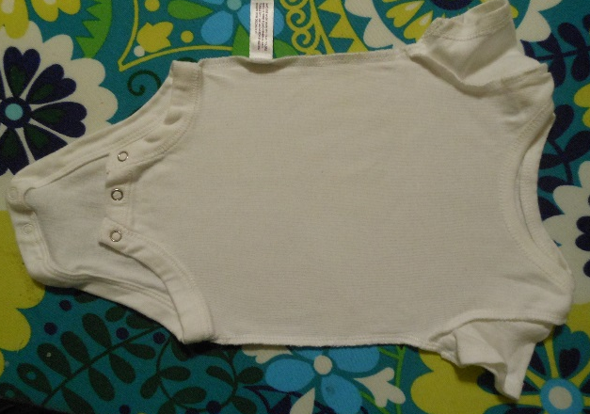

Step 2. Fold onesie in half to find center line, running from neck to snaps. I line up the armpit seams and side seams, then the overlap of the neckline. Press gently.
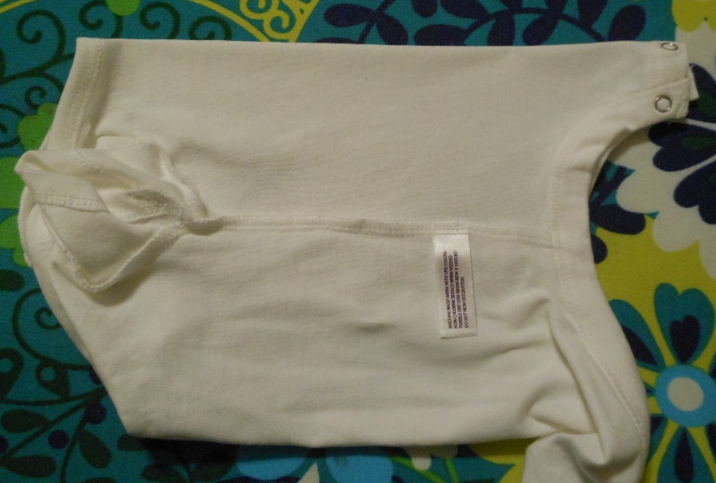
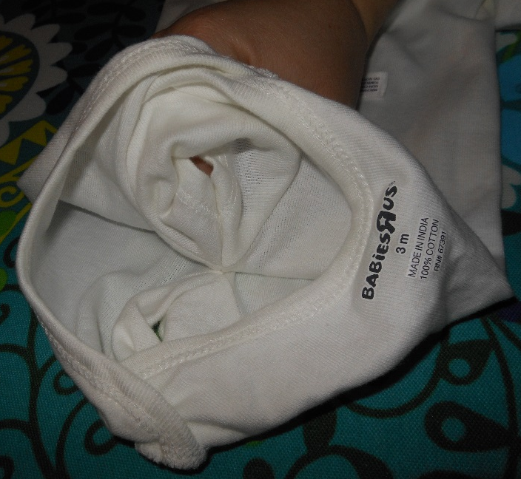
The two side seams should be laying on top of each other. Make sure everything is smooth before you press.
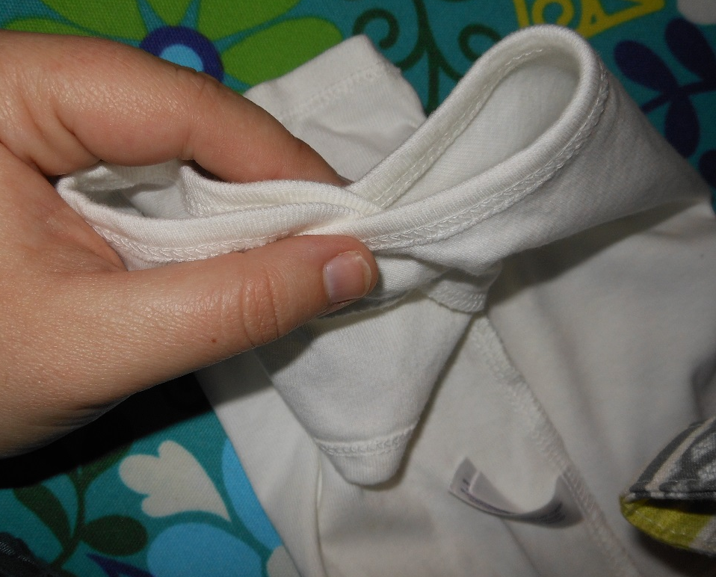

Step 3. Spread the onesie flat, still inside out. You should see the crease line marking the center. Print your design out at actual size, with grid lines. Match the vertical gridline with the center crease, and adjust until it is as far down as you want it. I usually do 2 or 3 fingers down from the neck. Poke a hole in the template and mark the center with your favorite disappearing pen. Mark the horizontal and vertical center points.
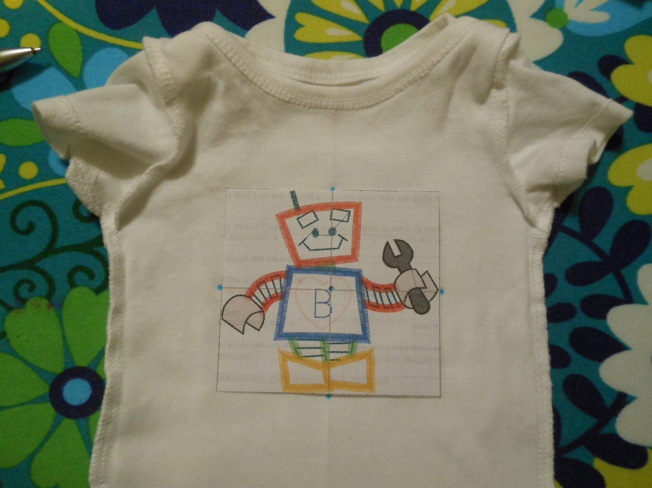

Step 4. Remove the template and use a ruler to draw a line across the horizontal center.
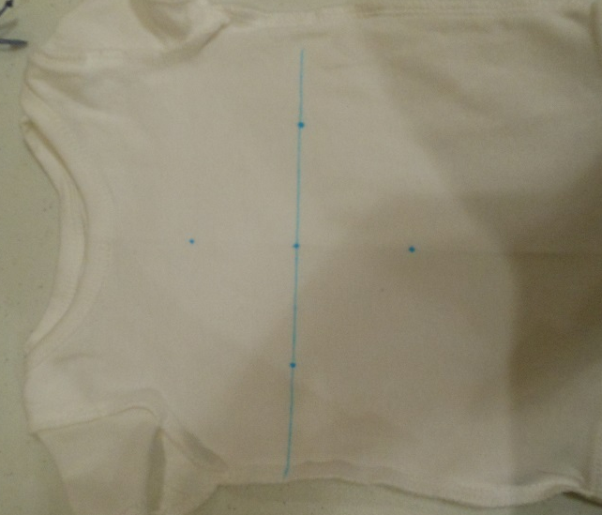
Step 5. Hoop a piece of cutaway stabilizer. Use the grid to mark the center points on the stabilizer. Remove the grid and use a ruler to draw the center lines. I have marked the center points on my inner hoop in marker using the grid. Spray the stabilizer with temporary adhesive.
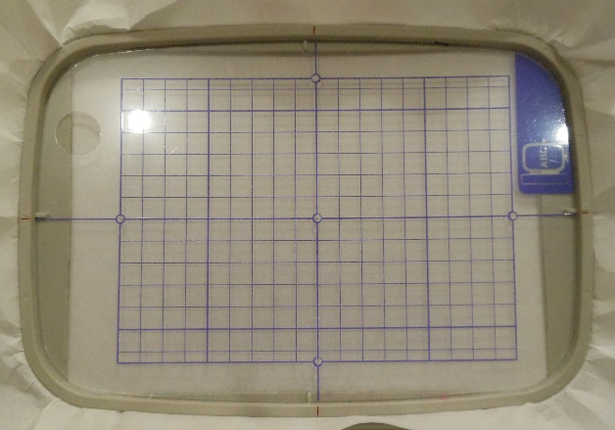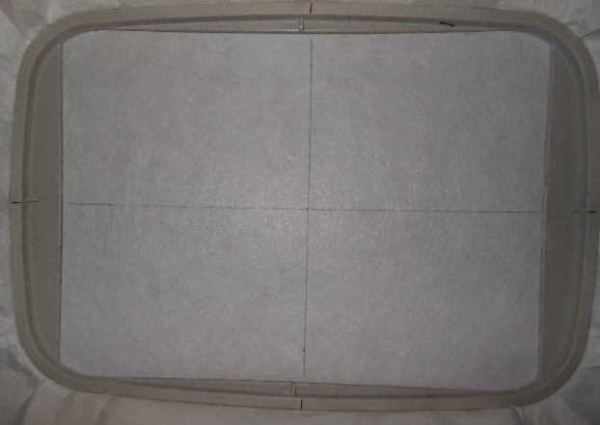

Step 6. With the onesie still inside out, fold it on the center line that you pressed earlier. Place it on the stabilizer, aligning the fold with the vertical line and the line you drew on the onesie with the horizontal line.
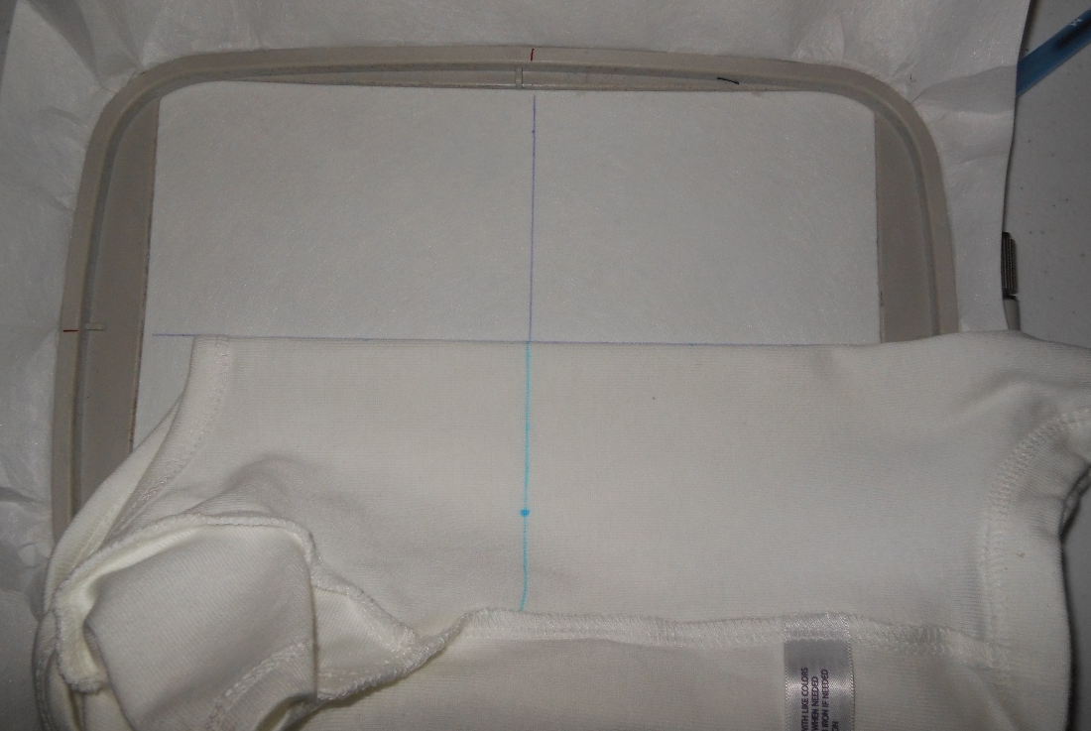

Step 7. Put your hand inside the onesie and smooth the fabric across the hoop, keeping the horizontal marks aligned. Make sure the fabric is smooth, but not stretched.
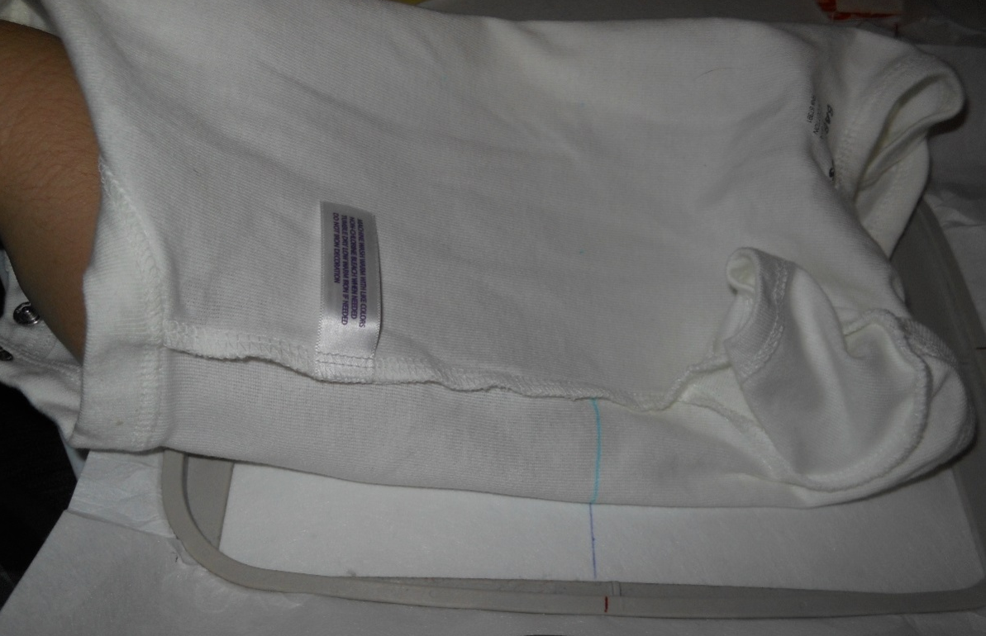

Step 8. Most people will say it’s overkill, but I also like to pin the onesie in place. I pin the top, bottom, and sides. Make sure everything is lined up horizontally and vertically. (I marked the vertical crease with dots to make it easier to see.)
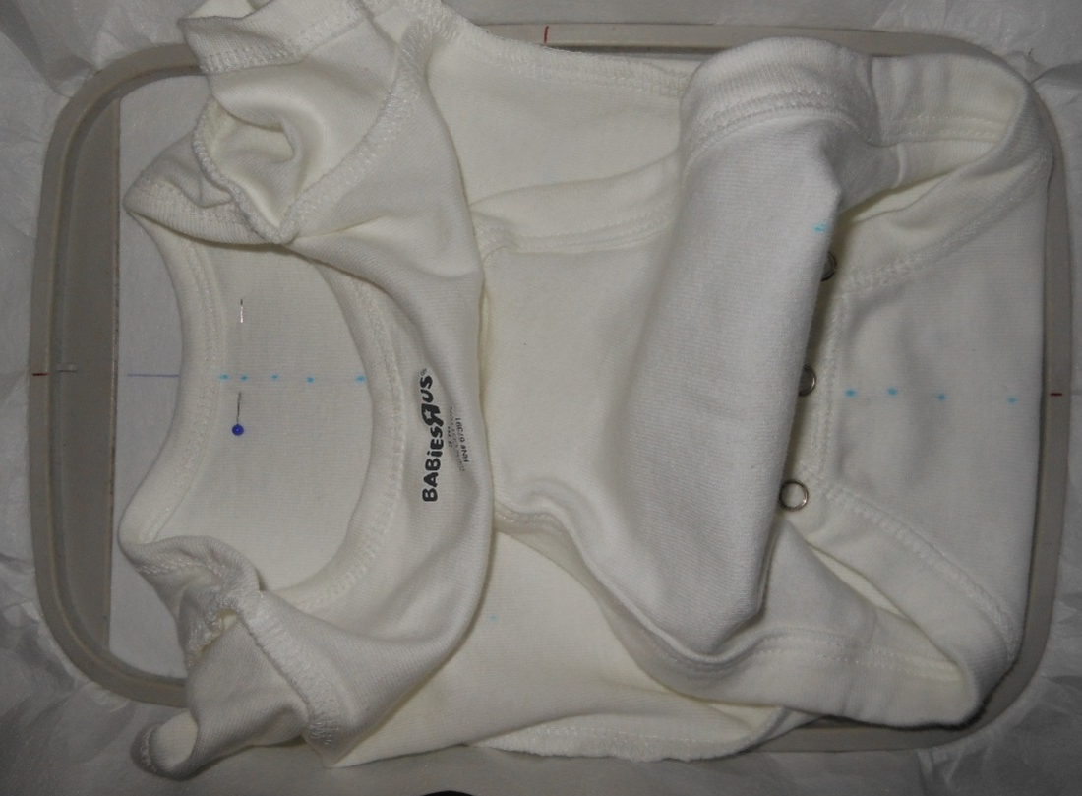

Step 9. Put the hoop on the machine. Pull the fabric out of the way, and make sure the needle hits the center mark. If the needle is not at the center and your design is small enough, you can adjust the layout until the needle is at the center. If you can’t move the design around, you have to decide if it’s far enough off to start over.
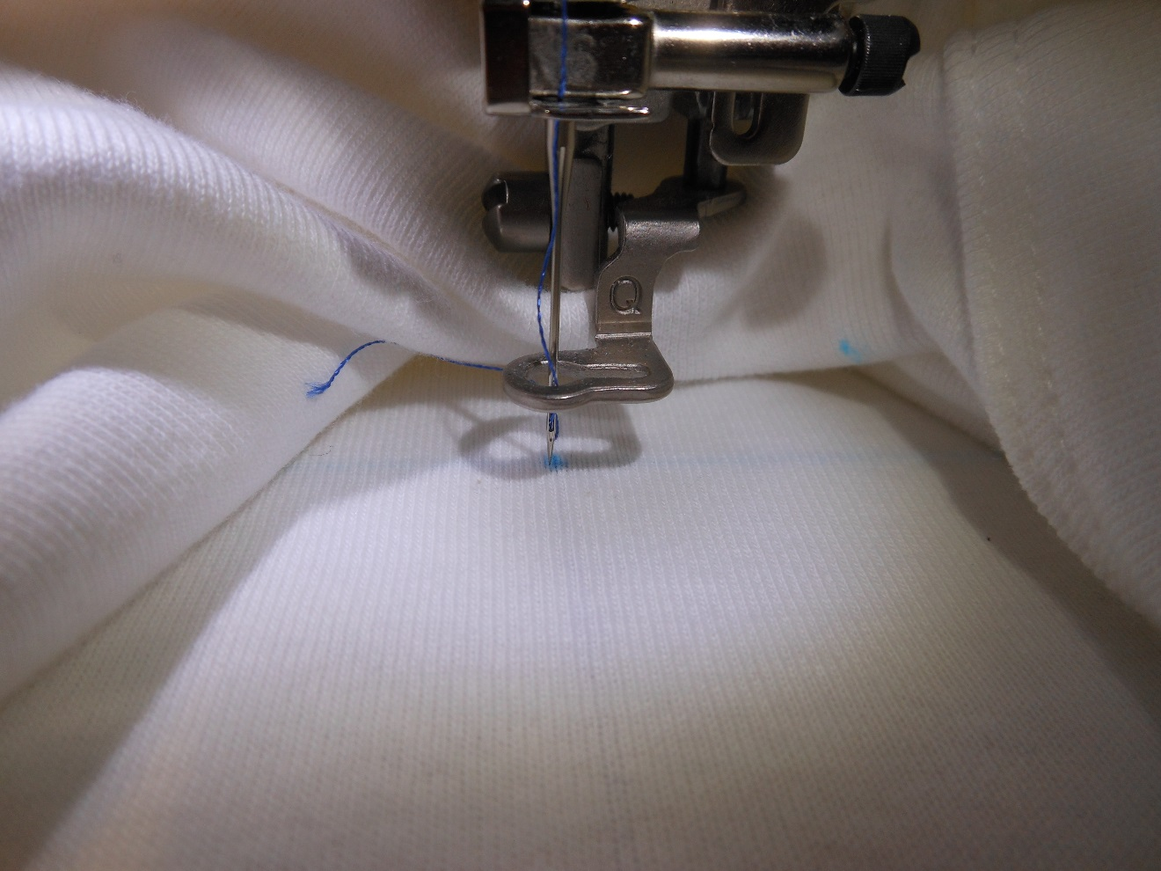

Step 10. Run a basting stitch around your pattern. Remove the pins to give you more room to work. Keep the excess fabric out of the way of the needle, but don’t pull on it or stretch it out of place. Baby sit the machine until it’s finished.

Note-On a newborn or 3 month onesie, I would normally use a 4”x4” pattern and hoop.

